Diffusion of Innovations Theory (Everett Rogers)
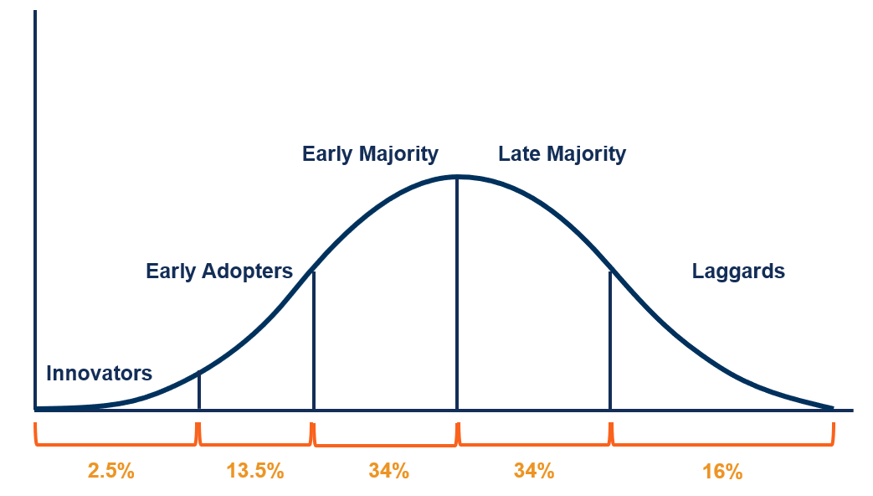

Diffusion of Innovations Theory, developed by Everett M. Rogers in 1962, explains how new ideas, technologies, or innovations spread within a society or social system over time. The theory focuses on the process through which an innovation is communicated through certain channels among members of a social system, emphasizing that adoption does not happen simultaneously for everyone. Instead, it occurs gradually as individuals evaluate, accept, or reject the innovation based on perceived benefits and social influences. Rogers defined diffusion as a process by which an innovation is communicated through specific channels over time among the members of a social system, highlighting communication and time as central elements in technological change.
An innovation refers to an idea, practice, or object perceived as new by an individual or group. The perceived “newness” is important because even long-existing technologies can be innovations to people encountering them for the first time. The diffusion process depends heavily on how individuals perceive the innovation’s usefulness, ease of use, and compatibility with their existing values and needs. Innovations that are perceived as superior to existing solutions tend to spread more rapidly than those offering minimal improvement.
Communication channels play a crucial role in diffusion. These are the means by which information about an innovation is transmitted from one individual to another. Mass media channels such as television, radio, and social media are effective in creating awareness, while interpersonal communication channels, such as discussions among friends, colleagues, or opinion leaders, are more influential in persuading individuals to adopt or reject an innovation. Opinion leaders, who are respected and trusted members of a social system, significantly influence diffusion by shaping attitudes and behaviors toward new technologies.
Time is a fundamental element in Diffusion of Innovations Theory and is examined in three ways: the innovation-decision process, the relative time with which an innovation is adopted, and the rate of adoption. The innovation-decision process consists of five stages: knowledge, persuasion, decision, implementation, and confirmation. In the knowledge stage, individuals become aware of the innovation and gain some understanding of how it functions. During persuasion, individuals form either a favorable or unfavorable attitude toward the innovation. The decision stage involves activities that lead to adoption or rejection. Implementation occurs when the innovation is put into use, and confirmation happens when individuals seek reinforcement for their decision and may continue or discontinue use based on outcomes.
Rogers categorized adopters into five groups based on how quickly they adopt an innovation. Innovators are venturesome individuals willing to take risks and experiment with new ideas. Early adopters are respected opinion leaders who adopt innovations early and help influence others. The early majority adopts innovations before the average person but prefers proven benefits. The late majority is skeptical and adopts innovations only after most people have done so, often due to social or economic pressure. Laggards are the last to adopt and tend to resist change, relying on traditional methods and past experiences.
The rate of adoption of an innovation is influenced by five key attributes: relative advantage, compatibility, complexity, trialability, and observability. Relative advantage refers to the degree to which an innovation is perceived as better than the idea it replaces. Compatibility measures how consistent the innovation is with existing values, experiences, and needs. Complexity refers to how difficult the innovation is to understand and use. Trialability is the extent to which an innovation can be tested on a limited basis, while observability relates to how visible the results of the innovation are to others. Innovations that score positively on these attributes diffuse more rapidly.
The social system provides the context in which diffusion occurs and includes individuals, groups, organizations, and institutions linked by shared norms and goals. Social norms, leadership structures, and change agents influence the diffusion process. Change agents, such as technology promoters or extension officers, actively encourage adoption by providing information and support. Cultural values, economic conditions, and political structures within the social system can either facilitate or hinder the spread of innovations.
Despite its wide application, Diffusion of Innovations Theory has limitations. Critics argue that it tends to favor technological determinism by assuming innovations are inherently beneficial and should be adopted. It may also overlook power relations, economic inequalities, and structural barriers that prevent certain groups from adopting new technologies. Additionally, the theory often focuses more on individual adoption decisions rather than institutional or systemic factors affecting diffusion.

Case Study: Diffusion of Mobile Money (M-Pesa) in Kenya
The adoption of M-Pesa mobile money services in Kenya illustrates Diffusion of Innovations Theory in practice. When M-Pesa was introduced, it was a new innovation that allowed users to send and receive money via mobile phones. Innovators and early adopters were mainly urban users and tech-savvy individuals who were willing to try the service despite uncertainty. Opinion leaders, including small business owners and community influencers, played a major role in convincing others of its benefits.
M-Pesa offered a strong relative advantage over traditional banking by providing fast, secure, and accessible financial services, especially to unbanked populations. Its compatibility with existing mobile phone usage made adoption easier, while its low complexity allowed even individuals with limited literacy to use it. Trialability was high because users could test the service with small transactions, and observability was strong as people could clearly see its benefits in daily transactions. Over time, the early majority and late majority adopted M-Pesa, making it a widely accepted financial tool, while laggards joined much later due to necessity and social pressure.

Questions and Answers
Question 1: What is Diffusion of Innovations Theory?
Answer: Diffusion of Innovations Theory explains how new ideas and technologies spread through a society over time via communication channels among members of a social system.
Question 2: Identify and explain the five stages of the innovation-decision process.
Answer: The stages are knowledge (awareness of the innovation), persuasion (forming an attitude), decision (adoption or rejection), implementation (use of the innovation), and confirmation (reinforcement of the decision).
Question 3: Who are early adopters, and why are they important?
Answer: Early adopters are respected individuals who adopt innovations early and influence others through opinion leadership.
Question 4: How do innovation attributes affect the rate of adoption?
Answer: Innovations with high relative advantage, compatibility, trialability, observability, and low complexity are adopted faster.
Question 5: Using M-Pesa as an example, explain how Diffusion of Innovations Theory applies in real life.
Answer: M-Pesa spread gradually through Kenyan society as users evaluated its benefits, were influenced by opinion leaders, and adopted it based on its advantages, ease of use, and visibility of results.

